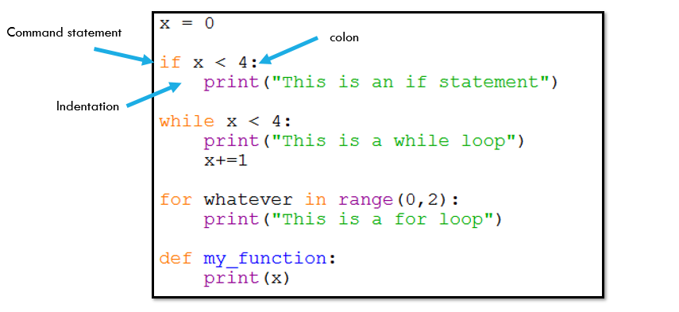

**Colors**

**Black:** data and variables such as x, 0

**Orange**: command statements such as if, while, for, def

**Purple**: functions such as print, input, len, open

**Green:** Strings